InterAct Ministries of Canada
Minutes of Board Meeting
August 19, 1997, 11:00 a.m.
Northeast Bible Church
Calgary, Alberta

Present: Tom Hook, Wilf Johnson, Ed Enarson, Gary Brumbelow, Daryl Kroeker, Jake Giesbrecht and Jim Goertz. Dale Smith and Jerry Crosby were also present.

1. Opening: Jake Giesbrecht opened the meeting with prayer.

2. Devotional: Chairman Tom Hook called the meeting to order and opened with a brief devotional from Genesis 1.

- Reading of Previous Minutes:

Minutes of previous meeting (Feb. 15, 1997) reviewed. Moved, Seconded, and Carried to accept as presented with corrections as noted below:

- Correction: Joint meeting chaired by Terry Hulbert. Canada meeting chaired by Tom Hook.

- Correction: “Gary suggested that full-time means at least 60 percent devoted to ministry” should read “Gary suggested that full member means at least 60 percent devoted to ministry.”

- Correction: “MSC to raise the required level by five percent (5%) for missionaries to Canada.” This contradicts an earlier (correct) minute, “MSC to adjust missionary salary levels to allow a nine percent cost-of-living increase for Canada personnel.”

- Correction: Next board meeting in Calgary at 10:30 a.m. August 19, 1997.

REPORTS

4. General Director Report Report presented by Gary Brumbelow, General Director.

5. Field Director Report Report presented by Dale Smith, Field Director.

6. Financial Report Report presented by Gary Brumbelow.

MSC to accept reports as presented.

7. Audit Committee

Tom Hook reviewed the minutes of the Audit Committee meeting that was held Tuesday morning the 19th of August 1997.

A motion was made to direct the board treasurer to review the monthly financial statement and compare them to the bank reconciliations. This is to be done on a monthly basis. MSC

A motion was made to add to the U.S. account signatories Dan Mayerle and Jim Goertz and to remove Les Cross. Also to add Jim Goertz as signatory to the Canadian account. MSC

A motion was made to recommend to the membership the appointment of Dart Bryant as auditor for 1998. MSC

OLD BUSINESS

8. Mission/Visions/Values Statement

The committee is working with the General Director on this project. Further information will be presented for discussion at our February 1998 board meeting.

9. Review board responsibilities

A motion was made to amend the Board Responsibilities:

- From “Bring to the planning process a thoughtful exegesis of the contemporary ministry environment by which to evaluate InterAct’s activities” to “Bring to the discussions an adequate grasp of relevant contemporary issues by which to evaluate InterAct’s activities.”
- And to add, “To ensure the organization’s continued adherence to its purpose.”

MSC

10. By-law revisions

Further revisions to the by-laws will be done in conjunction with our U.S. partner (InterAct Ministries, Inc.).

NEW BUSINESS

11. Insurance for indemnification of board members.

Dale Smith is going to look further into options and requirements and will report back to the board. To be reviewed when all information is available.

12. India Computer Training Proposal

Gary Brumbelow presented a proposal put forward by Serve Ministries. Proposal was discussed and reviewed. One concern raised was that this kind of project needs to be viewed as a means to an end, a way to achieve our purpose and not become our main reason for being there. This type of project needs to be monitored.

Motion was put forward to approve the proposal. MSC

13. Accommodations for board meetings.

Gary pointed out that accommodations for board members will be booked as double rooms unless the individual directs otherwise.

14. Capital Improvements Fund expenditure

Motion to authorize disbursements from the Capital Improvements Fund of $8,367.52 for office equipment for Native Bible Center. MSC

15. Election of Officers

Moved to nominate Jim Goertz as Chairman. Unanimous Ballot.
Moved to nominate Jake Giesbrecht as Vice Chairman. Unanimous Ballot.
Moved to nominate Daryl Kroeker as Secretary Treasurer. Unanimous Ballot.

16. Future Meetings

Next meeting will be a joint session with the InterAct Ministries Inc. board, February 28, 1998, at 9:30 a.m. in Portland. A Canada board meeting will follow the next day at 10:30 a.m. on Sunday the 1st of March 1998.

The audit committee will meet at 9:30 a.m. on March 1, 1998, in Portland.

- Audit Committee

Motion to replace Ed Enarson on the audit committee with Daryl Kroeker. MSC

- Native Pastors Fund

General Director and field director will approve requests for fund disbursements.

- Capital Improvements Fund

There was some discussion about the background and use of this fund. The General Director will research this and we will discuss it at our next meeting in February.

- Adjournment Motion to adjourn at 3:31 MSC

Respectfully submitted,

Jim Goertz
InterAct Ministries of Canada
Joint Board Meetings
February 28, 1998
Portland, Oregon
Canadian Board Minutes

Canadian Board Present: Rick Green, Daryl Kroeker, Wilf Johnson, Jim Goertz, Jake Giesbrecht, Gary Brumbelow

Call to Order & Welcome
1. InterAct Canada Board minutes will be recorded by Daryl Kroeker.
2. Announcements & housekeeping matters
3. Devotional: Matthew 14:22 (Tom Hook)
4. Board Member Introductions

Approval of Previous Minutes

General Directors’s Report
MSC to accept the report with appreciation.

Treasurer’s Report
Analysis & Commentary by Jerry Opp

Board Nominating & Review Committee Report
1. Review of Nominating & Evaluation Process by Larry Kroon.
2. Note: Canadian Board may want to follow a similar process for nominations and review of Canadian Board members.

Revised Member Handbook
Briefly reviewed by Jerry Crosby. Changes are only intended to remove clutter, organize the documents and move them toward a more professional presentation. There have been no changes in policy.

Finance Committee
1. MSC to exclude all outside income from calculation of maximum support and to no longer require reporting of the same. Staff will establish procedures to ensure accountability for the use of time.
2. MSC to increase maximum allowable moving expense reimbursement to $1000 when a missionary’s move is requested by InterAct.
3. The Finance Committee will study implications of moving toward a percentage based membership fee.
4. The Finance Committee will study implications of changes in policies of remuneration in term of years of services, education, ministry achievement etc.

General Director Relations Committee
Strong affirmation given to Gary Brumbelow, Jerry Crosby, Jerry Opp and Rollo Entz.

OLD BUSINESS
1. MSC to adopt the following statements:
Mission Statement: We exist to glorify God by fulfilling the Great Commission among unreached people groups.
Vision Statement: We want to see culturally relevant churches established and making disciples among unreached people groups of the world.

These above statements are to replace the current Purpose Statement found in the mission literature.

2. Child Abuse & Exploitation Prevention Policy
Policy was presented. To be reviewed by legal counsel for August meetings.

NEW BUSINESS
Alliance of Saturation Church Planting
MSC to end the relationship with the Alliance of Saturation Church Planting.

Board Discretionary Fund
MSC to raise to $10,000 the ceiling for undesignated gifts into the Board Discretionary Fund.

General Director Title Change
Discussion to revise the title of General Director to Executive Director. More research to be done on implications of the titles.

Budget
MSC to approve the General Fund Budget.

Change of Status
MSC to change the status of Gale and Jeanne Van Diest to semi-retired.

Account Signatories
MSC to approve wire transfers for Mike Matthews and change Oregon signatories to Jerry Crosby and Gary Brumbelow.

MSC Resolved that the secretary acting alone is hereby authorized, in connection with the wire transfers out of our accounts at Wells Fargo Bank, to designate persons who may request wire transfers and to execute and deliver such agreements, documents and other instruments, and to perform such other acts, relating to wire transfers as the secretary shall approve.

MSC Resolved: The board of directors authorizes entry in all agreements set forth in the Wells Fargo Business Account Disclosure which the board of directors acknowledges having read before any Account or feature contemplated thereby is used. The authorized signers can originate wire transfers or make telephone transfers. This resolution will remain effective until a new on is furnished to the bank by the board.

Future Meetings
The next joint meeting of InterAct Inc/InterAct Canada will be scheduled for February 20, 1999 in Portland, Oregon.

InterAct Ministries Canada Board Meeting Minutes
March 1, 1998 10:00 am
Portland, Oregon

Gary Brumbelow opened the meeting in prayer. Jim Goertz reminded us from 1Thessalonians of the importance of keeping perspectiveand balance in life.

Previous Minutes
MSC to adopt the August 19, 1997 Board Meeting Minutes.

OLD BUSINESS
Capital Improvements Fund (A strictly Canadian fund)
We clarified the governing policy of the CIF as:
1. Ten percent of the proceeds of all property sales shall be deposited in the Capital Improvements Fund.
2. The purpose of the Capital Improvements Fund is to facilitate the purchase of needed ministry equipment for InterAct Ministries of Canada.
3. The general director in consultation with the field director is authorized to approve disbursements.

We discussed the possibility of transfering the Capital Improvement Fund into the Board Discretionary Fund. Research needs to be done to determine what is in the CIF and the implications of such a transfer.

NEW BUSINESS
Stewardship Policy
MSC In keeping with recommendation of CCCC, we adopt the following and publish this policy to our constituents:
1. Each gift designated toward the support of an approved program or project of the organization will be used as designated with the understanding that when any given need has been met no redesignation will be made without consent of the donor.
2. Gifts cannot be accepted for projects what are not within the purposes of the organization or have not been approved by the governing board.
3. No portion of the remuneration of stewardship representatives and consultants is based on gifts received by the organization or gifts committed to it.
4. When, in the opinion of the organization’s stewardship representative or consultant, a gift might significantly affect the donor’s financial position or income or might adversely affect the donor’s relationship with family members, that donor will be advised and encouraged to seek independent professional advice before making the gift.
5. Comprehensive and current information regarding the organization and its ministries is available upon request.
6. InterAct annually prepares an audit which is available upon request.
7. InterAct is a full member of two financial accountability associations (Interdenominational Foreign Missions Association and Canadian Council of Christian Charities.)

1998-1999 Budget Proposal
MSC To approve the Budget as proposed.

Native Pastor’s Fund
The purpose of this fund and procedure for expenditures is spelled out in InterAct Ministries of Canada Policy Manual.

Ministry Expense Reimbursement
MSC To adopt the following policy:
Reimbursement of legitimate ministry expenses are paid upon receipt of records at the Calgary office. When extenuating circumstance make this impractical, a 30 day grace period for receipt of said records may be allowed .

Nominating Committee
MSC to nominate Jim Goertz, Daryl Kroeker, Jess Tanis. Noted that at our August 1998 meeting we will review the Nominating/Evaluation Process used by InterAct Inc.

Future Meetings
August 1998 - August 18 at 2:30 pm at Pine Lake
February 1999 - February 21, 1999 at 10:00 am in Portland

Moved to Adjourn
Respectfully submitted,

Dr. Daryl Kroeker
Secretary/Treasurer

InterAct Ministries of Canada
Board Meeting
August 18, 1998
Pine Lake, Alberta

Present: Dale Smith, Rick Green, Rollo Entz, Tom Hook, Wilf Johnson, Gary Brumbelow, Jake Giesbrecht, Daryl Kroeker.

Jake served as Chairman in Jim Goertz’s absence.

March 1/98 Minutes:
MSC to approve as written & distributed.

General Director’s Report:
MSC to accept the General Director’s Report.

Audit Committee Report:
MSC to accept the Audit Committee Report

MSC to accept the Auditor’s Report done by Dart Bryant Chartered Accountants.

MSC to recommend to the Members the appointment of Dart-Bryant as Auditor.

OLD BUSINESS

Capital Improvement Fund
At our last meeting we discussed eliminating this fund and rolling the balance in the InterAct Inc Board Discretionary Fund. Suggestion has been made to leave the CIF as is and not take any action at this time.

To assist us in making a future decision, at the next meeting we will review the purpose & policies guiding the CIF.

Indemnification
Dale Smith reported on the research done regarding costs of indemnification insurance as recommended by CCCC.

MSC To purchase the $2,000,000 Directors and Officers Liability Insurance policy offered by Robertson Hall Insurance Inc. if this policy covers Directors and all mission staff and personnel. To be reviewed in 1 years time.

Nominating Process
MSC To establish a Nominating and Review Committee.

MSC That the framework for this committee should consist of 2 Board Members and the General Director. The Board Members will be Wilf Johnson and Rick Green for a 1 year term beginning January 1999.

NEW BUSINESS

Canadian Council of Christian Charities
MSC to make a gift of $12,000 to Canadian Council of Christian Charities for helping with legal expenses.

Child Allowances & Support Schedule
MSC to eliminate child allowance figures from computation of salary and increase the salary figure by $700 per month (to $2600) for couples and $160 per month (to $1350) for singles, effective September 1, 1998.

Length-of-Service Increment
MSC to add a length-of-service increment to missionary salary as follows: 10% of salary at 5 years and additional 1% per year thereafter. Computation of length-of-service to begin at career service and includes service in other cross-cultural missions. Effective September 1, 1998.

Pension
MSC to increase the pension line item in the missionary support schedule from $115 to $170 for singles, and from $230 to $340 for couples, effective September 1, 1998.

Medical Insurance
MSC to add a medical insurance line item of $110 to the missionary support schedule, effective September 1, 1998.

Tax
MSC to increase the tax line item in the missionary support schedule from $120 to $260 for singles and from $175 to $375 for couples, effective September 1, 1998.

Special Assignment Policy
MSC to adopt the policy as attached.

Resignation Policy
MSC to adopt the policy as attached.

Conflict Resolution Policy
MSC to adopt the policy as attached.

Staff Resignations
The following resignations were received:
Ken & Janet Gibbs
Ed & Sharon Guyer

Election of Officers
MSC to elect the following:
Chairman Jim Goertz
Vice-Chairman Jake Giesbrecht
Secretary/Treasurer Daryl Kroeker

Future Meetings:
Joint Meeting with InterAct Inc. February 27, 1999 in Portland
InterAct Canada Meeting 1:00 pm February 28, 1999 in Portland
Audit Committee & Nominating Review Committees will meet
prior to the Board Meeting.

Respectfully submitted,

Dr. Daryl Kroeker Jake Giesbrecht
Secretary/Treasurer Vice-Chairman

InterAct Ministries of Canada
Minutes
February 27, 28, 1999
Portland, Oregon

Present: Jim Goertz, Rick Green, Wilf Johnson, Jake Giesbrecht, Daryl Kroeker, Gary Brumbelow

Also present for the February 27 session in which joint business was discussed were members of our partner organization, InterAct Ministries Inc.: Clarence Bakk, Charles Merriner, Huron Claus, Tom Hook, Tom Steffen, Bob Congdon, Larry Kroon, Jess Tanis, Rollo Entz, Jerry Crosby.

February 27 Session

Call To Order & Welcome

Devotional: Tom Hook spoke from John 3:16, reminding us of the importance of Christ in the message of forgiveness.

REPORTS:
General Director
MSC to accept the report as presented. Thanksgiving expressed.

OLD BUSINESS:

Alcohol/Tobacco Policy: MSC to adopt the following policy: Although the Bible does not expressly forbid the use of alcohol/tobacco, there are scriptural reasons for abstaining under certain circumstances. In any context where either the background or convictions of the people among whom we are serving, or the partners with whom we are working, include significant objections to the use of alcohol, InterAct missionaries are expected to abstain.

Adjournment of joint session.

February 28 Session

Also present at February 28 Session: Dale Smith, Jess Tanis.

Call to Order & Welcome

Previous Minutes:
MSC to accept the minutes of the August 18, 1998 meeting.

REPORTS:

Treasurer
MSC to accept the report.

Audit Committee
MSC to accept the report.

Nominating and Review Committee

MSC to adopt the following categories to be ideally represented on the InterAct Canada Board: Business, Finance, Legal, Pastor, Missionary Training, Missionary and Other.

We discussed a revision of our by-laws in regard to the minimum number of officers required on the Board.

MSC to adopt the following procedure for nominations;
a . At each Board meeting, members are asked to suggest possible nominees.
b. Each name is contacted by phone to alert them that a letter of information will be sent out.
c. This letter is sent, along with qualifications and expectations, and a questionnaire. After reviewing the materials, the potential nominee is given the opportunity to let his name stand or withdraw.
d. Those who elect to continue complete a questionnaire and return it to the designated member of the Board Nomination and Review committee.
e. The committee reviews the returned questionaires and submits qualified names to the Board for nomination at each winter meeting.
f. Upon Board approval, above nominees are informed that they are being nominated to the membership.
g. Completed questionnaires are distributed to the membership before annual meeting as per bylaws.
h. Members vote on a slate of nominees equal to the number of vacancies.

MSC to adopt the following list of qualifications for Board members:
a. Vigorous personal relationship with Christ
b. Demonstrated commitment to a local church
c. Unreserved agreement with InterAct’s doctrine, values, purpose and vision
d. Active involvement in missionary endeavor
e. Demonstrated potential for board governance
f. Willingness to invest personal time and energy in InterAct governance
g. Represents a linkage to key contacts

OLD BUSINESS

Capital Improvements Fund:
MSC to authorize $1000 for the purchase of hardware and software necessary to upgrade the receipting/accounting system in the Calgary office.

Purposes and Policies Guiding The Capital Improvements Fund:
Current fund amount - $22,699.00 We reviewed the purposes and policies of the CIF and agreed to leave the fund as is.

Indemnification Policy:
No action taken on decision of the August 18, 1998 meeting since the policy being considered did not meet conditions outlined.

MSC to purchase general liability that includes coverage for bodily injury, damage to others property, personal damage, abuse, harrassment and counselling.

Canadian Council of Christian Charities (CCCC)
MSC to table the financial request from CCCC until our August meeting.

MSC that we would like to give CCCC up to $12,000 and ask staff to raise these funds from our constituency.

NEW BUSINESS

Budget:
MSC to approve the Annual Budget.

Board Vacancy:
The resignation of Jess Tanis from the InterAct Canada Board was noted.

MSC to appoint Bob Miegen to fill the vacancy on the InterAct Canada Board subject to the review of the executive of the Board

Future Board Meetings:
1. InterAct Canada - August 24, 1999 in Calgary, Alberta
9-11 am Board Review & Nomination Committee
11-12 Audit Committee Meeting
1-3:30 pm InterAct Canada Board Meeting
2. InterAct Inc/InterAct Canada - February 26, 2000 in Portland, Oregon.

Adjournment

Respectfully submitted,

Dr. Daryl Kroeker Jim Goertz
Secretary/Treasurer Chairman

InterAct Ministries of Canada
Board Meeting Minutes
August 24, 1999
Calgary, Alberta

Present:
Board Members: Jim Goertz, Rick Green, Wilf Johnson, Jake Giesbrecht, Daryl Kroeker
Staff: Gary Brumbelow, Dale Smith, Jerry Crosby
Guest: Jess Tanis

Devotional: Jim Goertz shared from Philippians 4 and words of a song by Michael Card, reminding us to keep the eternal perspective in the work and ministry.

Previous Minutes: MSC to accept the minutes of February 27-28, 1999
It was noted that Bob Miegan was approached regarding the Board vacancy and declined.

General Director’s Report:
(1) A Powerpoint presentation was given regarding the future of InterAct.

(2) MSC to affirm that we are supportive of the formation of the Task Force to study the future of InterAct and would encourage the inclusion of an InterAct Ministries of Canada Board Member.

(3) MSC to accept the General Director’s Report.

Treasurer/Audit Committee Report:
(1) MSC to accept the report as given.

(2) MSC to recommend to the membership the appointment of Dart Bryant as auditor for 1999.

Nominating and Review Committee Report:
(1) MSC to accept the report.

(2) MSC to follow the procedure established by InterAct Inc. for the review of Board Members.

(3) MSC to appoint Daryl Kroeker to this committee.

Old Business:

(1) Alcohol/Tobacco Policy

MSC to adopt the following as our policy: Mindful of the background and culture of some of the people among whom and with whom we serve, InterAct requires its members to practice a lifestyle of abstinence from alcoholic beverages and tobacco.

(2) Stewardship Policy

MSC to adopt the following revised policy:

1. Gifts cannot be accepted for projects that are not within the purposes of the organization or have not been approved by the governing board.

2. Each gift designated toward the support of an approved program or project of the organization will be used as designated with the understanding that when any given need has been met, designated gifts will be used where needed most.

3. No portion of the remuneration of stewardship representatives and consultants is based on gifts received by the organization or gifts committed to it.

4. When, in the opinion of the organization’s stewardship representative or consultant, a gift might significantly affect the donor’s financial position or income or might adversely affect the donor’s relationship with family members, that donor will be advised and encouraged to seek independent professional advice before making the gift.

5. Comprehensive and current information regarding the organization and its ministries is available upon request.

6. InterAct annually prepares an audit which is available upon request.

7. InterAct is a full member of two financial accountability associations (Interdenominational Foreign Missions Association and Canadian Council of Christian Charities.)

New Business:

(1) Field Director Ratification: MSC to ratify the General Director’s appointment of Dale Smith as Canada Field Director for a four-year term.

(2) Bylaw Revisions: Copies have been distributed and will be voted on at our next meeting.

(3) Election of Officers: MSC to affirm the current list of officers.
Chairman: Jim Goertz
Vice Chairman: Jake Giesbrecht
Secretary/Treasurer: Daryl Kroeker

Thanks are expressed to Wilf Johnson for his six years of faithful service as a Board Member.

(4) Field of Ministry: MSC to approve Canada, the United States, Russia and India as official ministry fields of InterAct Canada.

(5) Future Meetings:

February 24, 2000 at Willingdon Church in Burnaby B.C. (4812 Willingdon Avenue)
6:30 am Nominating & Review Committee (Breakfast Meeting)
8:00 am Audit Committee Meeting
8:30 am Board Meeting

August 2-5, 2000 in the Portland area. This will include a retreat and Board Meetings.

Adjournment

Respectfully submitted,

Dr. Daryl Kroeker Jim Goertz
Secretary/Treasurer Chairman

InterAct Ministries of Canada
February 24, 2000
Burnaby, B.C.

Present:
Board Members: Jim Goertz, , Rick Green, Jake Giesbrecht, Daryl Kroeker.
Staff: Gary Brumbelow, Dale Smith, Jess Tanis.

Devotional: Daryl Kroeker

Previous Minutes: MSC to accept the minutes of August 24, 1999 as amended with the following:.

MSC To amend point 2 under the General Director's Report to read:
MSC to affirm that we are supportive of the formation of the InterAct Ministries Inc. Task Force to study the future of InterAct Ministries Inc. and approach them to consider the inclusion of an InterAct Ministries of Canada Board Member on that Task Force.

REPORTS

General Director’s Report:
[a] MSC To accept the General Director's Report.

Treasurer:
[a] Noted that both Jim Goertz and Daryl Kroeker are receiving and reviewing the monthly statements. All appears to be in order.

[b] Noted that we have received the last payment from the land sale in Quesnel. This will impact our income by approximately $1000 per month.

Audit Committee:
[a] MSC To accept the Audit Committee Report as presented.

[b] MSC To appoint Rick Green to the Audit Committee.

Nominating and Review Committee:
[a] MSC To accept the Nominating and Review Committee Report as presented.

[b] MSC To recommend Rick Green for nomination for re-election.

[c] Everyone on the current Board is encouraged to present the names of potential Board Members to the Nominating and Review Committee.

OLD BUSINESS

By-law Revision:
[a] MSC To amend the By-laws of InterAct Ministries of Canada as attached.

[b] Note: The amended By-laws must be submitted to the Minister of Consumer and Corporate Affairs for approval.

[c] MSC To recommend the ratification of the amended By-laws to the members.

Board Vacancy:
In light of the Nomination and Review Committee's schedule, this vacancy will be left until the August meeting.

NEW BUSINESS
Budget:
[a] MSC To adopt the 2000-2001 Budget as presented.

Bank Account Signature:
[a] MSC To remove Bob Moffat and add Kenn Stark.

Future Meetings:
[a] August 5, 2000 in Portland, Oregon.

[b] February 25, 2001 in Portland, Oregon.

Adjournment
MSC to adjourn.

Respectfully submitted,

Dr. Daryl Kroeker Jim Goertz
Secretary/Treasurer Chairman

InterAct Ministries of Canada
Board Meeting Minutes - August 4, 2000
Portland, Oregon

Present:
Board Members: Jim Goertz, Daryl Kroeker, Dave Bedford, Rick Green.
Staff: Gary Brumbelow, Dale Smith, Jess Tanis.

Devotional: Dave Bedford

Board Vacancy Note from phone call on April 11/00: It was MSC to appoint Dave Bedford to the InterAct Canada Board to fill the current vacancy.

Previous Minutes: MSC to accept the minutes of February 24, 2000.

REPORTS

Treasurer & Audit Committee:
MSC To accept the Treasurer and Audit Committee Report as presented.

Commendation given to Leila for a tremendous job!

Nominating and Review Committee:
Committee did not meet this time. We are pursuing other Board Members including Tim Seim who may be available in 2002. We discussed those currently serving on the Board and the length of their terms.

OLD BUSINESS
CCCC:
MSC That in light of the help of CCCC in securing religious order status and achieving ministerial housing allowance approval for at least two of our missionaries, to send them a gift of $5000.

The staff is encouraged to send them a letter of gratitude on our behalf.

NEW BUSINESS
Appointment of Auditor:
MSC To appoint Dart Bryant as Auditor for 2000.

Current fee is $5000 annual and they are doing a good job for us.

Committee Appointments:
MSC to appoint the following committees:
[1] Nominating & Review Committee: Rick Green & Daryl Kroeker
[2] Audit Committee: Jim Goertz, Daryl Kroeker, Dave Bedford

Election of Officers:
MSC to elect the following officers:
[1] Chairman: Daryl Kroeker
[2] Vice Chairman: Jim Goertz (unless term of office has expired and it will then revert to Rick Green)
[3] Secretary/Treasurer: Rick Green

Future Meetings:
To be announced.

Vision & Philosophy of Ministry Statements:
MSC to adopt the vision statement: " A culturally relevant church in every community in the North Pacific Crescent."

MSC to adopt in principle the following philosophy of ministry statements:

We will…
- Cooperate with other like-minded individuals, churches and organizations in reaching the people in this area.
- Live and learn in the culture.
- Locate in strategic communities.
- Focus all our ministries toward planting culturally relevant, mission-active churches.
- Address the physical, emotional and societal needs of the communities as well as the spiritual.
- Build team-based ministries.
- Work to promote healthy local leadership for the emerging and existing churches.
- Mobilize North American evangelicals for cross-cultural ministry.
- Provide the training necessary to equip people for effective ministry.
- Mobilize prayer for each unreached people group in this area.
- Do necessary research on all unreached people groups on our fields, maintaining a comprehensive database and making our findings available to other groups.
- Give appropriate attention to developing adequate financial resources to implement the vision.
- Develop a strong image enhancement process and materials (logo, literature, broadcast publicity, web, etc.)

Adjournment

Respectfully submitted,

Dr. Daryl Kroeker

InterAct Ministries of Canada Board Minutes
February 4, 2001

Present: Board members: Dave Bedford, Jim Goertz, Rick Green, Daryl Kroeker. Staff: Gary Brumbelow, Jess Tanis

The meeting was called to order by chairman Daryl Kroeker after sharing a devotional from Psalm 46 on “Rest Stops.” Prayer followed.

Previous minutes approved as submitted.

REPORTS

General director
The general director reported on a proposed move of the Canada office from Calgary to Carstairs. The move is to take place this summer possibly. The cost is expected to be about the same.
He also reported on a meeting of the Canada field director with Western Tract Mission. They had reportedly expressed interest in joining with InterAct Ministries but are not looking for a merger at this time. The suggestion was made to write a letter of interest.
MSC to accept the attached report.

Treasurer
The average missionary support is about 80% of recommended.

Audit committee
We discussion whether secretary/treasurer and chairman can comprise the audit committee. Staff will research this further and report at the next meeting.
MSC to accept the minutes as attached.

Nominating and Review Committee
Correction to be made to the Vacancies Chart to indicate that Rick Green’s membership on the board is not renewable as he is finishing a second term.
- New names were mentioned.
- Slate of nominees presented (as follows).
MSC to approve the above report.

MSC to make the following nominations to serve on the board beginning 2002: Dave Bedford, Tom Hook, Tim Seim.

OLD BUSINESS

NEW BUSINESS

Budget Moved to approve the 2001-2002 budget as submitted to the general director.
Field Ministries Fund
MSC to approve the Field Ministries Fund portion of the budget.

Stewardship and Accountability Policy Moved to revise the current policy (adopted August 24, 1999) as follows (replacing struck-through text with bolded text), which would then appear on all appropriate literature of the organization:

2. Each gift designated toward the support of an approved program or project of the organization will be used as designated with the understanding that when any given need has been met, designated gifts will be used where needed most.

“Spending of funds is confined to board approved programs and purchases. Each gift designated toward an approved program will be used as designated with the understanding that when any given need has been met, designated gifts will be used where needed most. Gifts are acknowledged and receipted with an official receipt for income tax purposes.”

Employee designations
Moved to designate Judy Paras as our employee, effective immediately.

Moved to designate Marlene Nelson as our employee, effective immediately.

Future meetings
We discussed the practice of our joint meetings with InterAct Ministries Inc and expressed satisfaction with the present structure.
Next meeting: August 12, 1:00 p.m., Anchorage.
Following meeting: Feb 9-10, 2002, Portland.

Moved to Adjourn: Carried.

Respectfully submitted,

Rick Green Dr. Daryl Kroeker
Secretary/Treasurer Chairman

Interact Ministries of Canada
Minutes of August 12th 2001 Board Meeting
Anchorage, Alaska. 2:00 PM

Present: Gary Brumbelow, Daryl Kroeker, Jess Tanis, James Goertz, and Rick Green via telephone.

Call to Order and Welcome

Devotional led by Daryl Kroeker

Reading of Previous Minutes of February 4th, 2001 meeting.

Motion to accept the minutes as presented. M/S/C.

General Director Report

Gary Brumbelow presented the General Directors report. Motion to accept report as presented. M/S/C.

Treasurers Report

Rick Green gave a brief update on the finances and accounting of Interact Ministries of Canada. He is currently reviewing the checks and monthly statements. Daryl is also reviewing the monthly statements. Motion to accept the Treasurers report as presented. M/S/C.

Nomination and Review Committee

The committee has presented three additional names and asked the General Director to contact them.

OLD BUSINESS

NEW BUSINESS

Missionary on the Board

Note: We would like to investigate the possibility of placing a missionary on the board. The board would like to ask the staff to investigate this a little further.

CCCC Standards

Motion to adopt the revised standards as presented by the CCCC. M/S/C.

Resignation

Motion to accept the resignation of Julia Keishian. M/S/C.

Capital Improvement Fund Disbursement

Motion to approve the request for funds for the office renovation expenses in the amount of $7,333.37. M/S/C.

Appointment of Auditor

Motion to appoint Dart Bryant as Auditor for this coming year. M/S/C.

Nominating and Review Committee Appointments.

Motion to appoint Tom Hook, Tim Seim, Rick Green, and Dave Bedford to the Nomination and Review committee. M/S/C.

Audit Committee Appointments.

Motion to appoint Tom Hook, Tim Seim, Rick Green, and Dave Bedford to the Audit committee. M/S/C.

Appointment of Officers

Moved to appoint Rick Green as chairman, Tom Hook as vice-chairman, and Dave Bedford as Secretary / Treasurer for the coming year. M/S/C.

Future Meetings

February 9 – 10, 2002 in Portland.
August 15, 2002 – Location To Be Announced.

Adjournment

Motion to Adjourn – M/S/C.

Respectfully submitted – James I. Goertz

InterAct Ministries of Canada
Board Minutes
February 10, 2002

Present: Rick Green (chairman), Dave Bedford, Tom Hook, Tim Seim
Staff: Gary Brumbelow
Guest: Jess Tanis

Rick Green called the meeting to order.
Tom Seim led in prayer.

The previous minutes were approved as distributed.

Reports

The General Director gave his report. MSC to accept.

The treasurer had nothing to report.

Minutes of the audit committee meeting were entered. (See attached.)

The Nominating and Review Committee minutes were also entered. (See attached.)
The committee recommended the nomination of Jim Goertz, John Russell, and Alan MacKenzie for board membership, terms to begin 1/1/03. MSC.

Old Business

Missionary on the board Although earlier discussions indicated that the CCRA does not prohibit employees from serving on the board, the General Director reported that further research shows that the issue is basic Canada trust law. In light of that, the proposal to elect an InterAct missionary to the board was dropped.

New Business

Signing authority MS to authorize the Canada field director to sign legal documents for InterAct Ministries of Canada. The motion was then amended to authorize the Canada field director to sign any legal document for InterAct Ministries of Canada which does not require the signature of an officer. Carried.

Budget MSC to approve budget as submitted. (See attached.)
The board instructed staff to prepare a finance report of the last 10 years to determine significant trends.
Three of the officers will meet with the auditor, field director and bookkeeper to clarify the financial procedures.

Loan from InterAct Ministries, Inc MSC to instruct staff to assign the interest income from the loan from InterAct Ministries, Inc (approximately $180,000 representing proceeds from the sale of the Baker Creek property) to the general operating expenses.

By-law revision MSC to revise the by-laws as attached subject to the ratification of the membership at the 2002 annual meeting. (See attached)

Bookkeeper We discussed the possible need in the future to hire an employee to do the bookkeeping. No action was taken.

Privacy MSC to approve the following policy: “Any personal information which InterAct Ministries of Canada may have about its beneficiaries is confidential and shall not be disclosed without due cause.”

Partnership agreement MSC to direct the General Director to revisit the relationship between InterAct Ministries of Canada and InterAct Ministries Inc. and bring a recommendation to the summer meeting.

Travel policy MSC to adopt the policy as submitted. (See attached.)

Retirement policy MSC to adopt the policy as submitted, with the revision that the membership fee will not exceed the standard career membership fee. (See attached.)

Auditor MSC to appoint Dart Bryant as auditor, subject to the ratification of the membership at the 2002 annual meeting.

Next meetings:
Aug 22, 1:00 p.m., Calgary. Place to be announced.
Feb 9, 2003. Portland

Moved to adjourn

Signed ____________________________________, Rick Green, Chairman

Signed ____________________________________, Dave Bedford, Secretary/Treasurer

InterAct Ministries of Canada
Board Minutes
August 22, 2002

Present: Rick Green, Tom Hook, Dave Bedford, Tim Seim. Staff: Gary Brumbelow, Dale Smith. Guest: Jess Tanis.

Dale Smith opened in prayer.

Chairman Rick Green read from the scriptures.

The agenda was approved with two additions:
- Software purchase proposal.
- Random funding proposal.

MSC to approve the minutes of the previous minutes as distributed.

Reports

The general director had verbally reported to the General Director's Relations Committee. MSC to approve that report, as well as the attached.

The treasurer reported on his meeting with the office staff about a month ago. He affirmed the accuracy of the staff reports being submitted. Due to less expense and more income than projected we are about $9,000 ahead of the projected balances. MSC to accept the report.

The audit committee reported on their meeting with the auditor (minutes attached). MSC to implement the auditor’s recommendations about the spreadsheet (see attached).

Nominative and Review Committee MSC to accept the Vancancies Chart as submitted (attached).

Old Business

Joint Ministry Agreement MSC to recommend the adoption of the attached Joint Ministry Agreement by the members.

Keishian Resignation Noted for the record that Julie Keishian’s last date of employment was 9/19/01.

New Business

Software purchase MSC to approve the expenditure of $6500 from the Capital Improvements Fund for the purchase of KMAi and related software and training as per the attached proposal.
Kasten request for building funding We reviewed a proposal for financial assistance to help the Grande Prairie native fellowship build a church building. After some discussion of the pros and cons, we concurred that: 1) InterAct Canada is not in a position to provide this kind of capital, 2) the Grande Prairie fellowship is not ready for this kind of responsibility, 3) such action would not be consistent with our investment policy. This will be communicated in writing to Ellis Kasten. MSC

Investment Policy MS to adopt the attached policy. After discussion, the motion was amended to adopt the policy as revised. MSC

Nominating and Review Committee appointments MSC to appoint Tom Hook, Tim Seim, Rick Green and Dave Bedford to the Nominating and Review Committee.

Audit Committee appointments MSC to appoint Tom Hook, Tim Seim, Rick Green and Dave Bedford to the Audit Committee.

Appointment of Officers MSC to appoint Rick Green as chairman, Tom Hook as vice-chairman, and Dave Bedford as Secretary/Treasurer for 2003.

Emergency Fund Proposal We discussed establishing an emergency fund for disbursement to missionaries to be governed by a policy to be drafted by management for presentation to the next meeting. The proposal will include the size of the fund as well as other particulars.

Future meetings
February 8-9, 2003 Portland
August 29, 2003 Calgary

Adjournment Adjournment declared by chairman.

Respectfully submitted,

Gary Brumbelow

InterAct Ministries of Canada Board Minutes
February 9, 2003
Portland, Oregon

Call to order & welcome
Reading of previous minutes

REPORTS

General director Received in the Joint Ministry Agreement Committee meeting.

Treasurer
We reviewed the Ants Winter Fund process. Staff is requested to set up this fund in the balance sheet each month to facilitate monitoring of the fund balance.
Missionaries will be made aware of the fund without mention of the amounts mentioned in the guidelines.
Moved by Dave Bedford, seconded by Alan MacKenzie, to approve the fund guidelines as attached. Carried.

Audit committee
See attached minutes.
We discussed expanding the responsibilities of the audit committee to include reviewing the budget. Tabled until summer meeting.

Nominating and Review Committee
See attached minutes.
Moved by Tim Seim, seconded by Tom Hook, to accept the above reports.

OLD BUSINESS

Joint Ministry Agreement Moved by Jim Goertz, seconded by Tim Seim, to approve the Joint Ministry Agreement as submitted. Carried.
The Joint Ministry Agreement Committee is comprised of the boards of InterAct Ministries of Canada and InterAct Ministries, Inc.

NEW BUSINESS

Budget Moved by Tom Hook, seconded by Tim Seim to approve the operating budget as submitted. Carried.

Ethics Code Recommended by the audit committee to adopt the attached Code of Ethical Fundraising and Financial Accountability. Carried.

Support schedule Moved by Tim Seim, seconded by Alan MacKenzie to approve the support schedule below, effective immediately:

Single Couple
Personal Allowances
Salary $1,485.00 $2,860.00
Housing $600.00 $900.00
Social Security/Taxes $290.00 $440.00

SUB-TOTAL $2,375.00 $4,200.00
Benefits
Retirement $170.00 $340.00
Medical $200.00 $400.00

SUB-TOTAL $370.00 $740.00
Ministry
Membership Fee $220.00 $440.00
Ministry Expenses varies varies

TOTAL $2,980.00 $5,410.00

Effective 7/1/03, the membership fee will be increased to the following figures:
Membership Fee $235.00 $470.00
Carried.

By-law change Moved by Tom Hook, seconded by Tim Seim, to approve the following revision (adding words in bolded text):
  - The Secretary/Treasurer
- shall see that an accurate record of the proceedings of the meetings of the Board of Directors and of the membership is kept and that all notices required under these By-laws are sent out; shall keep the seal of the Corporation,
Carried.

Membership Fee Moved by Jim Goertz, seconded by Tom Hook, to set a minimum membership fee of $190 per month per person regardless of missionary status, with a grandfather clause to existing missionaries, and that all full-time missionaries (defined as over 60 percent) pay the full career membership fee, effective 7/1/03. Carried.

Applicants with Public Health Risks Moved by Jim Goertz, seconded by Alan MacKenzie, to adopt the following policy for applicants with known public health risk diseases.
Such applicants may be accepted if:
- They receive an appropriate placement (i.e. ministry, visa availability and the informed consent of the Field Director).
- They obtain independent medical insurance and pay for their drugs.
- They are healthy (feeling well and without side effects).
- They are aware of and willing to accept the additional risks.
Carried.

This policy is to be revisited at the August 2003 Board Meeting.

Check signer Moved by Tom Hook, seconded by Dave Bedford, to authorize Dan Woodard to sign checks on behalf of InterAct Ministries of Canada. Carried.

Future meetings
August 19, 2003 To be announced
February 8, 2004 Portland
August x, 2004 To be announced

Adjourned

Signed

Dave Bedford, Secretary

Rick Green, Chairman

InterAct Ministries of Canada Board Minutes
August 19, 2003
Three Hills, Alberta

Present: Alan MacKenzie, Dave Bedford, Tim Seim, John Russell, Jim Goertz, Tom Hook, Rick Green. Also present: Jess Tanis, Gary Brumbelow. Dale Smith came into the meeting at the beginning to report.

John Russell was welcomed to his first meeting.

Previous minutes: Minutes of the previous meeting were read. These minutes had been distributed earlier. MSC to approve as read.

REPORTS

Field director Dale Smith shared briefly about his plans for the special assignment he began July 1. He mentioned that he is also reviewing whether or not he should continue to be available as field director after this year. He will make that decision by the end of December.

General director Gary shared a report including progress on the four Bold Steps. MSC to accept the report.

Treasurer Dave Bedford shared a report indicating income and expense comparisons over the past three years. Both income and expenses are down. The general fund balance has improved over the last few years. He also distributed the July 31 balance sheet and attached financial reports. MSC to accept the treasurers report.

Audit committee Minutes of the committee meeting were read. No actions necessary. MSC to accept the report.

Nominating and Review Committee Minutes of the committee meeting were read. It was noted that having a missionary sit in on the board is perceived as helpful. The director was asked to check with CCRA and the province of Alberta about the permissibility of having a staff person serve on the board, a practice which is strongly discouraged by CCCC. MSC to accept the report.

OLD BUSINESS
AIDS policy We adopted a policy in February and at the same time determined to revisit the issue at this meeting. MSC to rescind the policy adopted in February.
Canada Staff Assistance Fund The guidelines approved at the last meeting were not attached to the minutes. MSC to re-approve as attached.

NEW BUSINESS
Agency Agreement We discussed retaining Robert Hayhoe to draft an agency agreement to guide our relationship with InterAct Ministries Inc. After discussion, we agreed to move ahead with the Joint Ministry Agreement process. No action taken.

Native Bible Centre funding MSC to approve a fund-raising event to raise $15,000 to fund a Native Bible Centre project.

Secondment request MSC to second Dale and Debbie Kenyon to LifeSteps in India in keeping with our current policy.

Conflict of Interest Policy MSC to adopt the following policy:

InterAct Ministries has a mandate to operate above reproach both in the sight of God and man, including a commitment to the highest level of integrity and to avoid conflicts of interest.

Any potential conflict of interest on the part of any board member, staff, and/or their families shall be disclosed by such member in writing to the board at least annually and made a matter of record.

Conflicts of interest may arise in, but are not limited to: the supply of goods and services; the leasing of equipment; purchase or sale of real estate, investments or other property; and honoraria or royalties for properties or services provided by InterAct, its board, or employees.

When any such interest becomes relevant to any subject requiring action by the board or any of its duly constituted committees, the member having a potential conflict shall call it to the attention of the board or committee and the member shall not vote on the subject with respect to which he/she or a member of his/her immediate family has a conflict of interest, shall not attempt to influence the vote of any other member, and shall not be counted in determining the quorum for dealing with the subject with respect to which the conflict exists.

Any member who is excluded from voting because of such conflict of interest shall briefly state the nature of the conflict and answer pertinent questions of other members when such interested member's knowledge of the subject will assist the board or any of its committees.

The minutes of the meeting shall reflect that a disclosure was made, that the interested member abstained from voting, and that the member was not counted in determining the quorum for dealing with the subject with respect to which the potential conflict exists.

Field director ratification MSC to amend the bylaws as follows (deleting the struck-through text):
10.4 There shall be a Field Director appointed to a term of four years by the General Director, subject first to ratification by the Board of Directors and then to ratification by a two-thirds (2/3) vote of the members present and voting at a duly noticed meeting. He shall perform such duties as assigned to him by the General Director.

In case of vacancies occurring between Board meetings, the General Director shall have the power to fill the vacancy until a new Field Director is appointed and ratified.

Signing authority Moved to authorize Dan Mayerle, as acting Canada field director to sign any legal document for InterAct Ministries of Canada which does not require the signature of an officer.

Senior Missionary MSC to revise the Retired/Semi-retired policy by replacing the term “semi-retired” with the term “senior.”

Nominating and Review Committee appointments MSC to appoint Tom Hook, Tim Seim, and Alan MacKenzie to the Nominating and Review Committee.

Audit Committee appointments MSC to appoint Jim Goertz, John Russell and Dave Bedford to the Audit Committee.

Appointment of Officers MSC to appoint Tim Seim as chairman, Tom Hook as vice-chairman, and Dave Bedford as Secretary/Treasurer for 2004.

Future meetings
February 8, 2004 Portland
August 17 (first choice) or August 10 (second choice), 2004

Adjournment MSC to adjourn.

Signed

Rick Green, chairman

Dave Bedford, secretary

InterAct Ministries of Canada Board
Minutes
February 7, 2004
Portland, Oregon

Present: Alan MacKenzie, Dave Bedford, Jim Goertz, Tom Hook, John Russell, Tim Seim, Gary Brumbelow

Reading of previous minutes MSC to approve as distributed.

REPORTS

General director MSC to receive the report.

Treasurer Revenue is up slightly. The general fund continues to do pretty well, currently about $45,000. U.S. funds coming into Canada have suffered from the drop in the exchange rate which has negatively affected the support of some of our missionaries.

MSC to receive the treasurer’s report.

MSC to approve allocating $10,000 toward the Joint Ministries Agreement mobilization efforts.

Audit committee MSC to recommend to the membership Dart Bryant as auditor for the current fiscal year.

Quarterly financial reports will be sent to all board members: balance sheet, budget comparison, account balances and missionary support averages.

MSC to receive the audit committee report.

Nominating and Review Committee MSC to nominate the following:
  - Tom Hook
  - Daryl Kroeker for the “pastor” slot vacated by Tim Seim.
  - Rick Green
  - Dave Bedford

MSC to receive the Nomination and Review Committee report.

New Businesss

Revision of Joint Ministries Agreement MSC to revise the following Articles in the Joint Ministries Agreement:

Article 2.11(d) (Powers and Duties) as follows, replacing the struck-through text with the bold-face text:
“The JMAC shall, from time to time, appoint such officers or engage such persons as it considers necessary to carry out the functions described herein. The officers may be provided by the parties as described in Section 2.7 below above. The officers shall not be automatic voting members of the JMAC, except pursuant to a separate appointment as a voting member as described in Section 2.1. The officers shall have such duties as assigned to them from time to time by the JMAC.”

Article 4.3 (Retention of Records) as follows, replacing the struck-through text with the bold-face text:
“All records required to be kept pursuant to the Agreement, all financial information and books of account and all other documentation shall be retained at such locations as the parties shall determine from time to time the address of InterAct Ministries of Canada. The parties hereto shall have full access to such records and all copies of same shall be provided to any party upon written request.”

Article Article 5.2 (Contribution of Acquisitions) as follows, replacing the struck-through text with the bold-face text:
“Notwithstanding the foregoing provisions of this Section 5.2 or any other provisions in this Agreement relating to the disposition of Capital on the expiration or termination of this Agreement, InterAct Ministries of Canada may, in its sole and absolute discretion at any time during the currency of this Agreement, or at the expiration or termination of this Agreement, transfer, sell or donate the Capital, or any portion thereof, which it has contributed toward the Joint Ministry Activities to InterAct Ministries Incorporated a qualified donee or to such other party or parties as may be selected by InterAct Ministries of Canada on such terms and conditions as may be determined by InterAct Ministries of Canada in its sole and absolute discretion and, where the Capital has been acquired by both parties pursuant to subsection 5.2(b), the parties shall, subject to the provisions of subsection 5.2(c), use their reasonable best efforts to effect the purposes of InterAct Ministries of Canada under this subsection (e).”

Budget MSC to approve the 2004-2005 operating budget as submitted.

Canada field director appointment MSC to ratify the general director’s appointment of Dale Smith as Canada field director beginning 7/1/04.

Privacy Moved and seconded to approve a draft privacy policy. After discussion the motion was withdrawn. John Russell will review the policy and we will consider it at the next meeting. The staff was also asked to research what other organizations are doing to fulfill the privacy legislation.

Future meetings
August 10, 2004 Western Pentecostal Bible College, Abbotsford
February 5, 2005 Portland

Adjournment MSC to adjourn.
Recorder, Gary Brumbelow

Signed by Tim Seim, Chairman _______________________

Signed by Dave Bedford, Secretary/Treasurer _______________________

InterAct Ministries of Canada Board Minutes
August 10, 2004
Abbotsford, British Columbia

Present: Jim Goertz, John Russell, Alan MacKenzie, Tom Hook, Dave Bedford, Tim Seim. Staff: Dan Mayerle, Dale Smith, Gary Brumbelow. Guests: Jess Tanis, Daryl Kroeker

Chairman Tim Seim opened with a devotional from Luke 4 regarding the ministry of the Holy Spirit in the life of the believer.

MSC to approve the previous minutes were approved as distributed.

REPORTS

Field director
- The administrative dimension is going well, especially Chelene Williams’ work.
- The privacy issue is a current concern, as per the agenda for this meeting.
- Some of the native ministries are showing good leadership development, especially among some of the youth of late teens and early twenties.
- The Muslim ministry is continuing in equipping churches and outreach mailings. The Starks’ change of status and move to Wyoming will create significant change on this team.
- Missionaries in native ministry are struggling with aging issues and this will lead to some restructuring of team leadership to help address the need.
- Plans are in place to bring a videographer to Calgary soon to produce a recruitment video for our Asian/Arabic ministry.

General director Attached.

Treasurer General fund balance continues to climb, is now at about $60,000.

Audit committee The question was raised about the level of risk in our mortgage securities. Alan indicated the backed securities are first mortgages on Okanogan valley properties, and therefore the risk is very low. In the nine years and with $30 million in mortgages, their average rate has been about nine percent.

Audit committee minutes attached.

Nominating and Review Committee Committee minutes attached.

OLD BUSINESS
Privacy Policy MSC to adopt the attached policy.

NEW BUSINESS
Privacy Officer MSC to appoint Dan Mayerle as personal information compliance officer.

Premillenealism MSC to make the following revision to our Statement of Faith, replacing the struck-through text with bolded text:
We believe in the personal, premillennial coming imminent, bodily, visible return of our Lord Jesus Christ that will change history on for his saints and with his saints to reign a thousand years over this earth. We believe in the bodily resurrection of believers and unbelievers. Those who accepted Christ as Lord and Savior will be with him in heaven forever, and those who have rejected him will be separated from him in the lake of fire forever. (I Thess. 4:13-18; I Cor. 15:50-59; Rev. 19:19-20; 20:1-6; Matt. 25:41)

Charismatic Gifts MSC to replace our current Policy on Sign Gifts with the following policy:
Charismatic Gifts
For the sake of unity on a controversial matter, InterAct Ministries holds to the following:
- InterAct does not accept applicants who hold to the necessity of speaking in tongues as an evidence of salvation or of the baptism of the Holy Spirit.
- InterAct members agree not to promote doctrines that have been historically divisive such as speaking in tongues.

Alcohol/Tobacco Policy MSC to replace our current Policy on Members’ Use of Alcohol and Tobacco Products with the following policy:
Questionable Practices
In order not to detract from a good witness, InterAct members will refrain from ungodly practices, including but not limited to: substance abuse, drunkenness, unwholesome language, abortion, involvement in the occult and dishonesty (see Ephesians 4-5).

Gender Issues MSC to eliminate the first half of the policy The Role of the Missionary Wife as it appears below.

The Role of the Missionary Wife
From a Ministry Perspective . . .
1. Every believer is spiritually gifted, wives as well as husbands. (Rom. 12:4-8; I Cor. 12:4-31)
2. The wife is considered a missionary as well as her husband. After her responsibility to her family, the wife is expected to exercise her talents and spiritual gifts in missionary service through InterAct. Actual ministry work and the hours of work are to be negotiated between the husband and wife and the department director.
3. The following matters should be considered when establishing the ministry work load for the missionary wife:
a. Number and age of children. (It is assumed that as children mature, the wife’s responsibilities at home will decrease and she will gradually move into increased missionary responsibilities.)
b. Household conveniences. Because of varying living conditions at mission stations, the time required to manage a household will vary from location to location.
c. Family health.
d. Practical opportunities available to exercise her talents and spiritual gifts towards ministry goals.

New Category MSC to approve the member category “Intern” as attached.

New Ministry Initiative
We anticipate a telephonic Joint Ministries Agreement Committee meeting this fall to further discuss the proposal to invest in outsourcing development to McConkey Johnston.

MSC to approve a feasibility study of a new ministry initiative along the lines of the attached proposal. Concern was expressed that any new ministry needs to fit well with InterAct and have a sense of God’s direction.

Change of status MSC to approve the request from to change from career to senior missionary status for Charlie and Judy Cook effective 9/15/04.

MSC to approve the request from to change from career to associate missionary status for Kenn and Lesa Stark effective 1/1/05.

Nominating and Review Committee appointments The following were appointed: Tom Hook, John Russell, Daryl Kroeker³.

Audit Committee appointments The following were appointed: Dave Bedford³, Alan MacKenzie, Jim Goertz.

Appointment of Officers
Chairman: Daryl Kroeker³
Vice Chairman: Jim Goertz
Secretary/Treasurer: Dave Bedford³

Annual Meeting Chair Tom Hook or Gale Van Diest have been appointed as Chairman’s designee to chair the annual meeting of InterAct Ministries of Canada.

Future meetings
February 5, 2005 Portland
August 4, 2005 TBA

Adjournment Moved to adjourn.

Signed

Tim Seim, chairman

Dave Bedford, secretary

InterAct Ministries of Canada Board Minutes
February 5, 2005
Portland, Oregon

Present: Dave Bedford, Jim Goertz, Alan MacKenzie, John Russell, Daryl Kroeker, Tom Hook. Staff: Gary Brumbelow

The Doctrinal Statement and conflict of interest disclosure were distributed and signed.

The previous minutes were approved as read.

REPORTS

General director (Received at the Joint Ministries Agreement Committee meeting earlier.)

Treasurer Operational Ministries fund in good condition. Staff Assistance Fund is being used more.

Audit committee MSC to recommend Dave Dart to serve as auditor.

Nominating and Review Committee The committee recommended the following three renewable members to serve another three-year term commencing 1/1/06. MSC to nominate all three.

OLD BUSINESS

Budget MSC to approve the 2005-2006 budget as submitted.

Staff Assistance Fund MSC to revise the policy as follows: Any grant of taxable income will add 25% to the amount requested in order to help offset the additional income taxes and any such costs that will accrue to the missionary.

North American Field Ministries Director MSC to ratify the appointment of Jack Teeter as North American Field Ministries Director.

Kenyon Secondment MSC to approve their request to extend their secondment to LifeSteps in Chandigarh, India, a second year, April 1, 2005 to March 31, 2006.

Change of Status MSC to change the status of Ellis and Dottie Kasten from career to senior missionary, effective August 1, 2005.

Future meetings
August 4, 2005 Abbotsford
February 4, 2006 Portland

Adjournment
Signed

Daryl Kroeker, chairman Dave Bedford, secretary

InterAct Ministries of Canada Board Minutes
August 4, 2005
Abbotsford, British Columbia

Present: Jim Goertz, Tom Hook, Dave Bedford, Alan MacKenzie, John Russell. Daryl Kroeker sent regrets. Staff: Dale Smith, Gary Brumbelow.

Vice-chair Jim Goertz called the meeting to order.

The minutes of the previous meeting were approved after the following correction: The three renewable members whose names were omitted from the minutes are Jim Goertz, Alan MacKenzie and John Russell.

REPORTS

Field director Dale Smith shared highlights of his written annual report. He reported an encouraging year in Canada field ministries.

General director Gary Brumbelow shared highlights of his written annual report. He reported a challenging year but is encouraged by the progress of change.

Treasurer Everything looks good.

MSC to accept the above reports.

Audit committee The following items were moved by the committee:
- The statement on Section 7, “no directors are on both boards” is not accurate and should be deleted as Tom Hook and Daryl Kroeker serve on both boards.
- Re internal controls, the staff was instructed to propose an appropriate control system for review by the board at the next meeting.
- Re the need to diversify our investment portfolio, the field director was instructed to report at the next meeting with alternatives for some portion of our portfolio.
- Re control over the Mission Creek investment accounts, we recognized the need to establish proper control. Therefore, we instructed staff to perform the following and report back to the board:
- Provide a standing order to any investment firm with InterAct holdings instructing them that any withdrawals are to be deposited only to InterAct Ministries Crossfield CIBC account;
- Provide a standing order to any investment firm with InterAct holdings requiring them to provide confirmation of withdrawal or change requests to Roy Martin.
- The audit is to be made available to anyone upon request. Announcement of this will be made at the annual membership meeting and by written notice to our donors via a receipt insert.
- Recommend to the membership the appointment of Dart Bryant to perform next year’s audit.

Seconded. Carried.

Nominating and Review Committee The committee did not meet so there was no report.

Staff Assistance Fund Policy MSC to revise the policy by adding the following: “Disbursements to cover counseling costs require a report from the counselor to an InterAct member care staff member indicating satisfactory progress.”

New Category MSC to approve the member category “Mid-term” as attached.

Nominating and Review Committee appointments The following were appointed: Tom Hook (chair), John Russell, Daryl Kroeker.

Audit Committee appointments The following were appointed: Alan Mackenzie, Jim Goertz, Dave Bedford (chair).

Appointment of Officers The following were appointed:
Chairman: Daryl Kroeker
Vice Chairman: Alan MacKenzie
Secretary/Treasurer: Dave Bedford

Annual Meeting Chair Tom Hook was appointed as the chairman’s designee to chair the annual meeting of InterAct Ministries of Canada.

Future meetings
February 4, 2006 Portland
August 15, 2006 TBA

Adjournment MSC to adjourn.

Jim Goertz, Vice chairman

Dave Bedford, secretary
Personnel Categories

Mid-term Members

Time Expectation: Mid-term missionaries are generally expected to work full time, as defined by at least 40 hours per week. However, they are required to work at least the amount of time commensurate to the amount of support they are receiving, down to a minimum of 60 percent full time. Example: A mid-term missionary is working full time (40 hours/week), but is only receiving 80% support. His options are 1) receive approval from his supervisor to work 32 hours/week, or 2) continue working full time as an undersupported missionary. For some positions, full-time involvement is required and option 1 is not available.

Voting: Mid-term members have a voice, but no vote, in mission business.

Finances: Mid-term members are subject to a published mid-term member support schedule. Mid-term members may receive finances through regular support, secondary employment income, non-employment income, or any combination thereof.

Term: The term lasts from 6-24 months and may be terminated by the individual or mission at
any time. Shorter commitments may be renewed up to a maximum of 24 months.

InterAct Ministries of Canada Board Minutes
February 5, 2006
Portland, Oregon

Present: Daryl Kroeker, chair, Tom Hook, Dave Bedford, Jim Goertz, Alan MacKenzie, John Russell. Staff: Gary Brumbelow, Mike Matthews

The chairman called the meeting to order

The minutes of the previous meeting were approved as distributed.

REPORTS
General director (Received at the Joint Ministries Agreement Committee meeting earlier today.)

Treasurer Total giving YTD is down about $20,000 from last year. The Staff assistance fund is about $6,000. General Fund is in good condition. Income has been pretty flat for several years. Missionary support is averaging 55-60 percent of recommended support. The exchange rate is hurting many Canada missionaries who have U.S. funding.

Audit committee The staff have recommended new control procedures (attached) which the committee affirmed to be reviewed in one year for the effectiveness and the usefulness. MSC to direct the staff to implement these procedures.

Nominating and Review Committee There are no immediate vacancies to be addressed. The staff is being encouraged to review InterAct’s donor list for possible names to be considered at a later meeting. One potential member was discussed, Bob Neufeld of Williams Lake.

Budget MSC to approve the 2005-2006 budget as submitted.

Staff Assistance Fund MSC to revise the policy to add 25% to the amount requested in order to help offset the additional income taxes and any such costs that will accrue to the missionary.

Kenyon Secondment MSC to approve their request to extend their secondment to LifeSteps in Chandigarh, India, to 9/1/2008.

Canada field director appointment MSC to ratify the general director’s appointment of Dan Mayerle as Canada field director, effective 9/1/06.

Future Meetings
August 15, 2006 Abbotsford, BC
February 3, 2007 Portland, Oregon

Adjournment

Signed: Chairman, Secretary/Treasurer

InterAct Ministries of Canada Board Minutes
August 16, 2006
Abbotsford, British Columbia

Present: Jim Goertz, Alan MacKenzie, John Russell, Dave Bedford, Tom Hook, Daryl Kroeker.

Chairman Kroeker called the meeting to order and led in opening prayer.

The previous minutes were approved as distributed.

REPORTS

Dan Mayerle, acting Canada Field director, gave a verbal report of the current field ministry situation, touching on aspects of Asian/Arabic, First Nations, East Indian Ministries as well as administrative matters. A recent appeal letter, the first in many years, drew a very strong response of over $5,000. MSC to receive this report.

General Director, Gary Brumbelow, highlighted some of the salient points of his written report attached. We spent time discussing the current situation re the strategic planning process. MSC to receive this report.

Treasurer Dave Bedford reported that we are doing well financially, mentioning balances of the main accounts. The audit committee discussion included how to handle surplus funds. The U.S. organization is calling their note (approximately $143,000 representing proceeds from the sale of the Baker Creek property). MSC to receive this report.

The Audit committee recommended accepting the audit and appointing (subject to member ratification) Dave Dart once again to do the audit, with the proviso that the audit be filed in a more timely manner. MSC to receive this report. MSC to approve the audit. MSC to make the audit available to anyone upon request. MSC to recommend to the members the appointment of Dart Bryant. MSC to board direct the staff to have those reports to the auditor by May 1.

Nominating and Review Committee chairman reported on three upcoming vacancies which will need nominations at the February meeting. Dave Bedford (cannot be renewed), Daryl Kroeker (not available to serve) and Tom Hook (available). Three names (Stan Schiek, Ian Lawson, Rick Green) were considered which will likely be brought to the February meeting following further staff review and appointments as deemed necessary. MSC to receive this report.

OLD BUSINESS

NEW BUSINESS

CCCC recommendations
Re the recommendation #7 (that our financial statements and accompanying notes be reviewed by Canadian legal counsel) we requested board member attorney John Russell to discuss this further with CCCC. Staff will facilitate this conversation.

MSC to revise our designations policy as follows and to print it on all appropriate literature: Spending of funds is confined to board approved programs and projects. Each restricted contribution designated towards a board approved program or project will be used as designated, with the understanding that when the need for such a program or project has been met, or cannot be completed for any reason determined by the board, the remaining restricted contributions designated for such program or project will be used where needed most.

Corporate Resolution Authorizing Stock Transfers MSC to approve the following:
Resolved that the Chairman, Daryl Kroeker, the Vice chairman, Jim Goertz, the Canada field director, Dan Mayerle, or any one of them acting individually, are hereby authorized to sell, buy and endorse for transfer, certificates representing stocks, bonds or other securities now registered or hereafter registered in the name of this corporation.

Calgary South Asian Church Agreement MSC to approve an attached agreement with Calgary South Asian Bible Fellowship. Calgary South Asian agreement.doc

Employee designations
MSC to designate Glenna Houston as our employee, effective 9/1/2006.

Nominating and Review Committee appointments
MSC to appoint Tom Hook, Daryl Kroeker, John Russell

Audit Committee appointments
MSC to appoint Dave Bedford, Jim Goertz, Alan MacKenzie

Appointment of Officers MSC to appoint the following:
Chairman: Daryl Kroeker
Vice Chairman: Jim Goertz
Secretary/Treasurer: Dave Bedford

Annual Meeting Chair
Tom Hook or Rick McLeod have been appointed as the chairman’s designee to chair the annual meeting of InterAct Ministries of Canada.

Future meetings
February 3, 2007 Portland
August 14, 2007 Kelowna

Adjournment MSC to adjourn.

Daryl Kroeker, Chairman

Dave Bedford, Secretary

InterAct Ministries of Canada Board
February 3, 2007
Portland, Oregon

Present: Daryl Kroeker, Alan MacKenzie, Jim Goertz, John Russell, Tom Hook. Dave Bedford was absent due to illness.

Chairman Kroeker called the meeting to order.

The Doctrinal Statement, and conflict of interest disclosure were distributed for signature.

The minutes of the August 2006 meeting were approved as distributed.

REPORTS
General director Received at the Joint Ministries Agreement Committee meeting earlier today. See attached JMAC minutes.

Treasurer Included in Finance Committee report below.

Audit committee Reported on follow-up reports from staff about two items: 1) Staff control procedures, and 2) Investment portfolio update. MSC to accept committee report.

Nominating and Review Committee This committee recommended the following for nomination: Rick Green and Daryl Kroeker, for a three-year term beginning 1/1/2008. MSC to nominate these two to the membership.

Budget MSC to approve the 2007-2008 budget as submitted.

Matthews’ Agreement MSC to approve the attached.

Retirement MSC to approve a request for retirement by Betty Kirsch 6/1/2007.

CCCC The general director and John Russell reported on the reply to CCCC re recommendation #7 per minutes of our August 2007 meeting.

Future Meetings
August 14, 2007 Kelowna, BC (Alan MacKenzie will arrange a venue and accommodations as requested.)
February 2, 2008 Portland, Oregon

MC to adjourn

Signed: Daryl Kroeker, Chairman, Jim Goertz, Vice-Chairman

________________________ _______________________
InterAct Ministries of Canada Board
August 14, 2007
Kelowna, British Columbia

Present: Dave Bedford, Jim Goertz, Tom Hook, Daryl Kroeker, Alan Mackenzie. Staff: Gary Brumbelow and Dan Mayerle.

Daryl Kroecker opened with a devotional on Psalm 121 and prayer.

The minutes of the previous meeting were approved as distributed. M/S/C

REPORTS

Field director
Dan Mayerle gave the Canadian Field directors report. He included an update on the status of our missionaries, changes to the East Indian Ministries team, and staff update. M/S/C to accept this report.

General director
Gary Brumbelow presented the General Directors report. Gary highlighted some of the recent discussions among the GDC. Gary also indicated that Gale Van Diest will be the interim field director for the Alaska field. M/S/C to accept this report.

Treasurer
Dave Bedford presented the treasurers report. The finances of the organization are in good shape. Dave also gave a summary of the staff assistance fund. M/S/C to accept this report.

Audit committee
The Audit committee presented their report. This included the review of the Auditors report. The committee recommended the acceptance of the auditors report. M/S/C to accept.

There was a discussion regarding the investment funds and the motion to move the funds from the mortgage investments to short term GIC’s. M/S/C.

Recommended to open an account with ING. The motion is attached. Board motion to authorize this resolution as attached. M/S/C.

Nominating and Review Committee
Nominating and review committee presented their report. M/S/C to accept this report.

NEW BUSINESS

T3010A Dave Bedford, Treasurer, signed the T3010A.

Corporate Resolution Authorizing ING Account
[5/10 note from Dan re procedure] “This is a savings account only and funds will not be directly accessed from this account. Any fund transfers will be directly linked to InterAct Canada’s CIBC chequing account and will be accounted for.”

Member Handbook Member Handbook – Moved to approve the handbook as distributed with the deletion of the section of senior membership. M/S/C.

IMCO Donations IMCO Donations - Moved to approve the IMCO 2007 conference (August 15-19,2007) as a board approved project. M/S/C.

By-Laws Revision Moved to revise the By-Laws as attached to reflect policy changes made to differentiate between membership and employment. M/S/C

Task Force Moved to appoint a Task Force to study the question of how InterAct should respond to the growing presence of aboriginal Christians ready to serve in ministry. M/S/C This task force will report to the General Director's Council.

Missionary Retirement Moved to approve the request from Charlie and Judy Cook to change status from Senior Missionary to Retired, effective 12/31/07. M/S/C

Nominating and Review Committee appointments
Moved to appoint Daryl Kroeker, John Russell

Audit Committee appointments
Moved to appoint Jim Goertz, Alan MacKenzie, Rick Green

Appointment of Officers Moved to appoint the following:
Chairman: Daryl Kroeker
Vice Chairman: Jim Goertz
Secretary/Treasurer: Rick Green

Annual Meeting Chair
Moved to appoint Dan Mayerle or Wally Bays as the chairman’s designee to chair the annual meeting of InterAct Ministries of Canada. M/S/C

Future meetings
February 2, 2008 Portland
August xx, 2008 TBA

Adjournment

InterAct Ministries of Canada
Minutes of Board Meeting
1:30 PM February 2, 2008
Portland, Oregon

Present: Daryl Kroeker, Alan MacKenzie, Jim Goertz, John Russell, and Rick Green.

Chairman Kroeker called the meeting to order.

The Doctrinal Statement and conflict of interest disclosure were distributed for signature by the board members.

The minutes of the August 14th, 2007 meeting were approved as distributed.

REPORTS
General Director Received at the Joint Ministries Agreement Committee meeting earlier today. See attached JMAC minutes.

Treasurer Included in Audit Committee report below.

Audit committee Reported on follow-up reports from staff about four items: 1) Staff control procedures, and 2) Clarification Re: Dave Dart’s comment regarding $26,000.00 materiality, and 3) Decision to remain with Dave Dart as auditor, and 4) Investment portfolio update.
MSC to accept committee report. See attached Audit Committee minutes.

Nominating and Review Committee This committee recommended the following for nomination: Andy Baxter, Dave Bedford, and Larry Sayers, for a three-year term beginning 1/1/2009. MSC to nominate these three to the membership.

Budget MSC to approve the 2008-2009 budget as submitted.

Chilcotin Project MSC to approve the Chilcotin project for funding as an approved ministry project.

Future Meetings
August 12, 2008 Strathmore, Alberta - 50 Slater Road, Strathmore, Alberta.

MC to adjourn

InterAct Ministries of Canada Board Minutes
August 12, 2008
Strathmore, Alberta

Present: Daryl Kroeker, Jim Geortz, Alan MacKenzie, Rick Green, John Russell, Gary Brumbelow. Canada field director Dan Mayerle was also in attendance.

Chairman Daryl Kroeker led in prayer and called the meeting to order

The minutes of the February meeting were approved as sumbitted.

REPORTS

Field director Canada field director Dan Mayerle read a report (attached) followed by Q&A and an affirmation of Dan’s work by the chairman. MSC to accept the report.

General director General director Gary Brumbelow read a report (attached) also followed by Q&A and further discussion. MSC to accept the report.

Treasurer& Audit committee Minutes of meeting preceding the board meeting attached.
MSC to accept the audit’s report per the recommendation of the committee.
MSC to leave the balance in the ING account [see audit committee miunutes for wording] to be reviewed February 2009.

Nominating and Review Committee This committee did not meet. Three new members (Baxter, Bedford, Sayers) are on the ballot at the annual membership meeting this week.

NEW BUSINESS

T3010A The T3010A was approved and signed.

By Law Changes MSC to recommend the following by law revisions to the members at the annual meeting.

Add new paragraph | 2.5 All members are members in good standing unless they resign or are removed by the Board of Directors pursuant to the By-laws.
Add new paragraph | 2.6 Any member who, in the opinion of the Board of Directors, has violated these By-laws or Regulations prescribed by the Board of Directors, or whose conduct is prejudicial to the welfare of the Corporation may be expelled from membership by the Board of Directors.
Add bolded text | 12.4 No error or omission in giving notice of any annual or general meeting or any adjourned meeting, whether annual or general, of the members of the Corporation shall invalidate such meeting or make void any proceedings taken thereat; and any member may at any time waive notice of any such meeting and may ratify, approve and confirm any or all proceedings taken or had thereat. For purpose of sending notice to any member, director or officer for any meeting or otherwise, the address of the member, director or officer shall be his last address, whether an e-mail or regular mailing address, recorded on the books of the Corporation.
New wording | All references to “general director” changed to “executive director.” Comprises seven changes under article 10, e.g., “The Board of Directors shall elect an Executive General Director subject to the ratification of a two-thirds (2/3) vote of the voting membership. The Executive General Director shall be the chief executive officer of the Corporation operating under the control of the Board of Directors.”

Assessment MSC to approve the change in the membership contribution assessment from a flat fee (for full members) of $220, noting the following particulars:
- Assessment would be 10% of all direct and indirect contributions to support for service related to InterAct, with a minimum of $125.
- Retired staff to be assessed at half the active staff rate.

Office Administrator Plan MSC to approve the attached proposal with one abstention from Jim Goertz.

Account signers MSC to make the following change to our CIBC & Clackamas accounts signatories: Remove Dale Smith, add Wes Schellenberg

Nominating and Review Committee appointments
MSC to appoint Andy Baxter, Larry Sayers, Rick Green, Gary Brumbelow

Audit Committee appointments
MSC to appoint Dave Bedford, Daryl Kroeker, Gary Brumbelow

Appointment of Officers MSC to appoint the following:
Chairman: Daryl Kroeker
Vice Chairman: Rick Green
Secretary/Treasurer: Dave Bedford

Annual Meeting Chair
MSC to appoint Dan Mayerle or Dan Woodard as the chairman’s designee to chair the annual meeting of InterAct Ministries of Canada.

Future meetings
February 6-7, 2009 Portland or Vancouver, B.C. (to be announced) beginning with half-day strategic planning discussion Friday, committee meetings Friday afternoon, board meetings Saturday.
August 16-17, 2009 Seattle or Strathmore to be announced
February 11-13, 2010 Phoenix (pending consensus)

Adjournment MSC to adjourn

InterAct Ministries of Canada Board Minutes
February 7, 2009
Portland, Oregon

Present: Daryl Kroeker (chairman), Andy Baxter, Dave Bedford, Rick Green, Larry Sayers, Gary Brumbelow

The meeting was called to order by the chair.

It was Moved, Seconded and Carried to approve the minutes of the previous meeting as distributed.

REPORTS
Executive director This report (summary attached below) had been received at the Joint Ministries Agreement Committee meeting earlier today. The Executive Director also reported on the changes in the IMCO association, i.e. the reconstitution of this association to a biannual talking circle including, and led by, First Nations leaders. MSC to accept the Executive Director report.

Audit committee/Treasurer The committee had reviewed our investment portfolio (CIBC and ING) and recommended making no changes to same. MSC to accept the report.

Nominating and Review Committee The committee (Baxter, Sayers, Green) recommended the nomination of Alan MacKenzie to a three-year term beginning 1/1/2010. MSC to nominate Alan per that recommendation.

Change of Address MSC to amend the bylaws to reflect the change of InterAct’s office address as follows:
P.O. Box 60029
Strathmore, AB T1P 0C2

CCCC Our continued full membership will require the following steps:
- Amend our bylaws to include our doctrinal statement,
- Amend our bylaws to include the requirement that directors, officers and key employees must indicate their agreement with the doctrinal statement in writing as a condition of appointment to office or to employment
- Adopt a Code of Moral Conduct/Lifestyle
- To undertake an evaluation of at least one of our programs, such evaluation to be completed and the results reviewed by the board at the August 2009 meeting.
The Executive Director will determine the importance of full CCCC membership to corporate funders (foundations). Depending on those findings, we will either comply with the above requirements or reduce our CCCC membership to associate status.

Budget MSC to approve the 2009-2010 budget as amended (as follows):
Ministry Expense (column Admin & General) changed from 21,600 to 32,400
Executive Salaries (same column) changed from 39,540 to 28,740

Authorized signers MSC to remove Wes Schellenberg and add David Nelson. (This makes Dan Mayerle, Dan Woodard and David Nelson official signers.)

Venture Teams International MSC to gift $1,068.00 to Venture Teams International.

Future Meetings
Aug 10, 2009 Strathmore
Feb 4-6, 2010 Portland

MC to adjourn

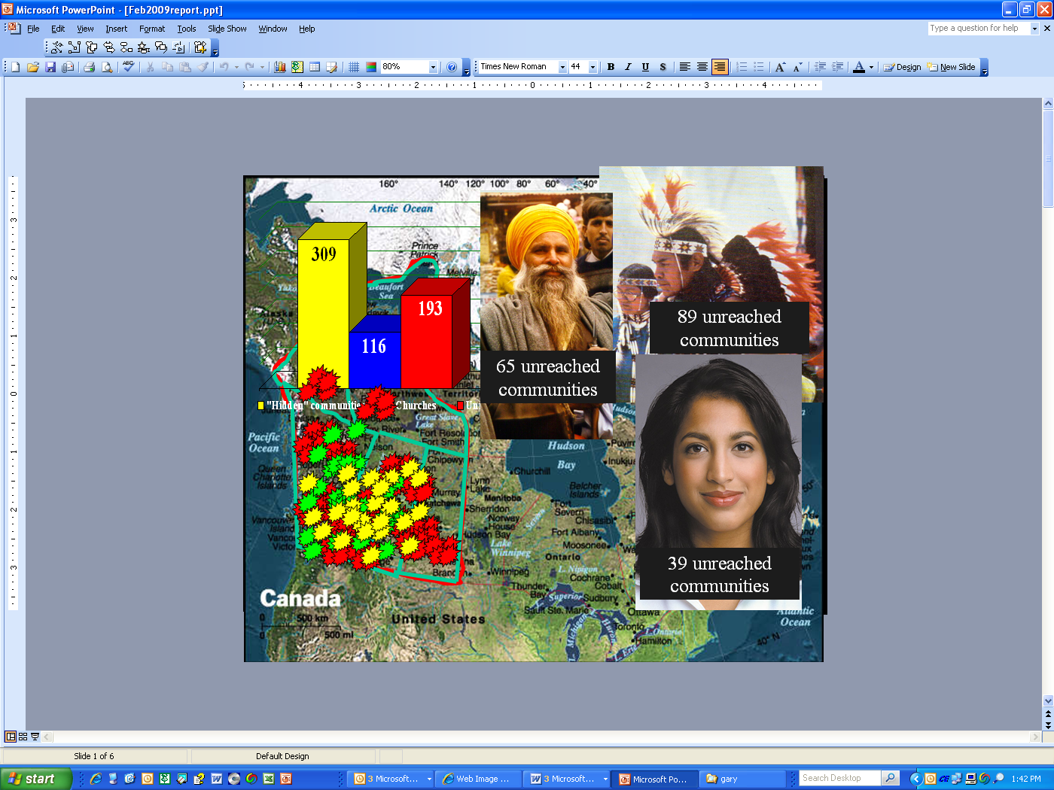
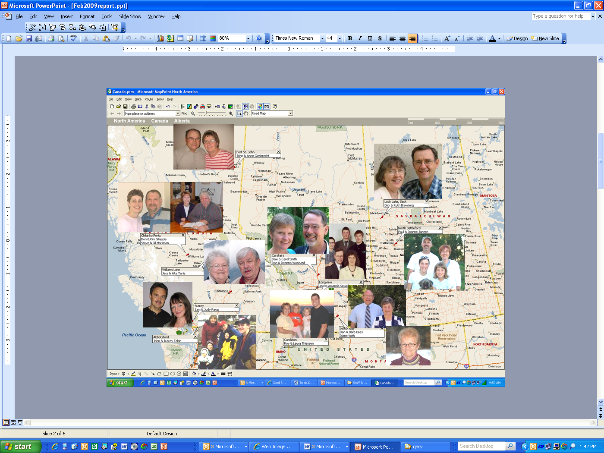
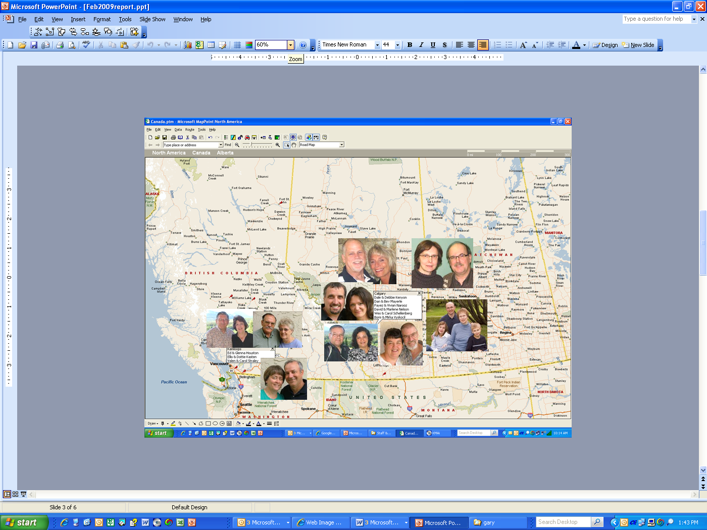
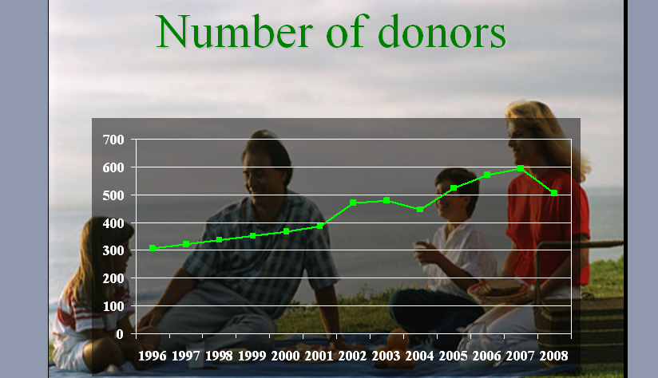
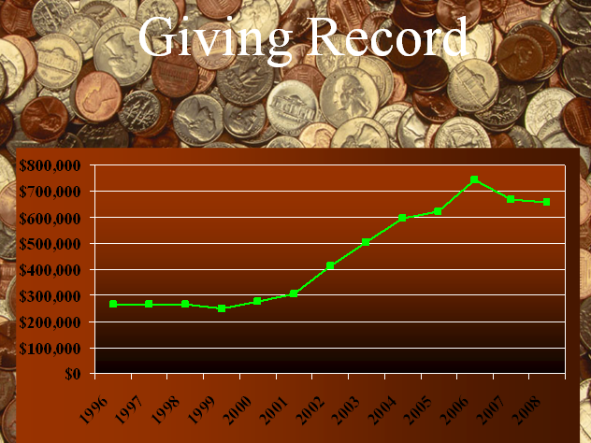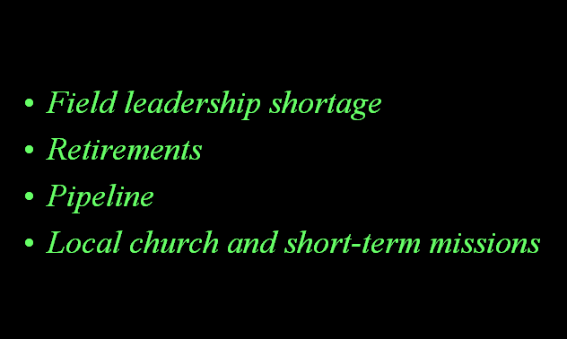
InterAct Ministries of Canada Board Minutes
February 6, 2009
Portland, Oregon

Present: Daryl Kroeker, Alan Mackenzie, Dave Bedford, Rick Green, Andy Baxter. Staff: Dan Mayerle, Gary Brumbelow
The meeting was called to order by chairman Daryl Kroeker.
The minutes of previous meeting were approved as read.
Reports
The report of the Executive Director was received and accepted in the JMAC meeting earlier in the day.
Finance & Audit committee. See attached minutes. MSC to transfer $225,000 from savings to three TWU promissory notes: one year, two year, three year to take advantage of a higher interest rate and the least amount of risk.
Nom & Review committee See attached minutes. MSC to nominate Rick Green and Jim Goetz (pending his approval) to three-year terms beginning 1/1/2011.
New Business
Exec Director resignation MSC to accept Gary Brumbelow’s resignation from the position of executive director effective 2/28/2010.
Executive Director appointment MSC to appoint Dale Smith to the Executive Director position effective 3/1/2010, subject to ratification by the members. Note: funding for this position is to be worked out in concert with InterAct U.S. over the coming year. [Note for clarification: InterAct Canada is employer of Dale Smith as Executive Director.]
Exec Director Job Description MSC to approve the executive director job description as follows:
Job Description
Executive Director
InterAct Ministries
February 6, 2010

Summary

The vision of InterAct Ministries is to see a culturally relevant church transforming every community in the North Pacific Crescent. We believe that the gospel has the power to bring about whole-life transformation in individuals, families and communities, pictured by reconciliation and wholeness. Such an audacious goal cannot be achieved without strong support. The Executive Director is the public face of InterAct Ministries and gives special attention to building InterAct’s capacity to help achieve this vision.

The executive director interfaces with InterAct leaders to plan ministry programs designed to advance our vision and attract participation. By this means he will be positioned for strong mobilization of staff and partners to build the capacity necessary to fulfill InterAct’s vision.

Relationships

- Responsible directly to the Board of Directors.
- Chairman of the Executive Director’s Council.
- Works closely with Field Directors and administrative leaders toward the achievement of InterAct’s vision.
- Provides spiritual leadership to the ministry of InterAct.

Activities

- Participates in the mobilization of new missionaries by personal involvement in recruitment activities.
- Mobilizes new financial partners and cultivates existing partners by face-to-face relationship building.
- Articulates the vision of InterAct Ministries before its constituency.
- Works closely with individual Field Directors in strategic planning and in defining key action points that will achieve InterAct’s vision on their respective fields.
- Holds Field Directors accountable for adhering to the vision and accomplishing the mission of InterAct on their fields.
- Communicates regularly with the members of the Board, apprising them of all significant developments.
- Works with the Board Chairman to develop meeting agendas designed to enable the Board to function effectively in its governing role.
- Reports to the Board of Directors at all meetings of the board.
- Is accountable to the Board for the execution of policies and directives.
- Facilitates communication between the field members and members of the Board.

CCCC Membership Proposal to change our membership level from full to affiliate. In view the appointment of a new executive director, this decision was tabled until the August meeting.
Doctrinal Statement in Bylaws MSC to amend our bylaws by including our doctrinal statement. This will require ratification by the membership at the annual meeting.
Gladstone Mountain Gathering Grounds This property, which currently belongs to NAIM, has been used by InterAct and others for camping ministries for several years. We have an opportunity to lease or purchase the property for continued camping as well as developing a missionary-recruitment vehicle. A users group including First Nations people (and missionaries) is asking us to take the lead. We fully agree that the camp comprises a valuable ministry and we want to support the group, but InterAct does not have the capacity to purchase or operate the camp. If the camp is purchased and a lease option becomes available we will reconsider partnering with the users group in a lease.
Child/Youth Abuse Policy A draft will be reviewed by counsel and then sent to the board members for review to be acted on at the August meeting.
Budget MSC to approve the 2010-2011 budget revised as follows:
- Adding $10,000 for executive director expenses
- Adding up to $2500 per month for executive director salary (diminishing until personal support is raised, to be reviewed at each board meeting)
Future meetings
- August 9, 2010 Gladstone
- February 3-5, 2010 Portland
Adjourned
Respectfully submitted,

Gary Brumbelow

NOTE: The following has been incorporated into the minutes above.
InterAct Canada Portland, OR 6 February 2010
Convened jointly with InterAct, Inc. in separate Board session to work through procedural matters related to replacing the Executive Director.
Present: Daryl Kroeker, Dan Mayerle, Alan Mackenzie, Dave Bedford,
Rick Green, Andy Baxter
1. Executive Director
MSP – Motion to accept resignation of Gary Brumbelow, Executive Director,
effective February 28, 2010.
Moved: Dave Bedford Second – Alan Mackenzie
MSP – Motion to appoint Dale Smith Executive Director effect March 1,
2010, subject to ratification by the members.
Moved: Andy Baxter Second – Rick Green
[Note for clarification: InterAct Canada is employer of Dale Smith as Executive Director.]
2. Funding for Executive Director
Agreed that funding be worked out in concert with InterAct, Inc. over the
coming year.

Andy Baxter, recorder

Moved, seconded and carried.
Moved, seconded and carried.
Pending membership election this week.

